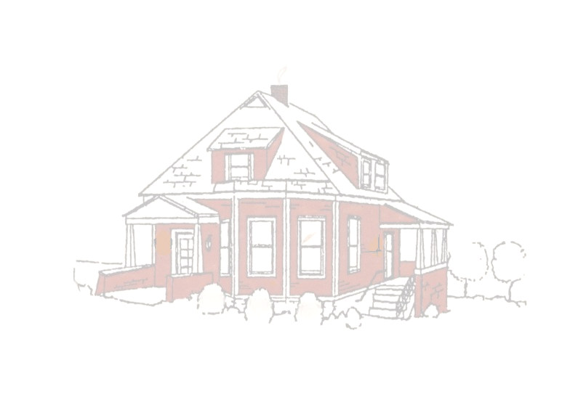
July - September 2010
~ Historical Times ~

A publication of the
Fenton Historical Society

W H E R E T H E P A S T A N D T H E P R E S E N T M E E T

ELECTION RESULTS

On June 3, the Fenton Historical Society held their Annual Meeting and elected officers and directors. Following are the results of that election: Vera Glick, President; Carol Veillette, Vice President; and George Luebbers, Treasurer. Patty Hunt was elected to fill the one available position of Director. The position of Secretary remains open, but should be filed by the time this newsletter is received. For those who chose to take a respite from holding an office the Society would like to extend a hardy thank you for the time and effort you expended to make the Society a success. And to the new officers and directors, congratulations and thank you for volunteering your services as we work toward our ever present goal of improving and revitalizing the Society.

FHS Officers

President
Vera Glick

Vice Presicent
Carol Veillette

Secretary
Open

Treasurer
George Luebbers

Directors
Whit Wallach (11)
Brenda Nenninger (12) Patty Hunt (13)

2010 ANNUAL SPRING LUNCHEON
We did it again!! The hard-working Committee for the Continued Success of the Annual Spring Luncheon (Claire, Brenda, Don and Vera) outdid themselves. For those unable to attend, please join us next year – we miss you.
And what made this event so special? Our guests, of course, and the ever-wonderful Silent Auction items, the beautiful donated quilt, the fantastic food, the weather and, last but not least, our favorite antique expert, Joan Komlos.
The Society would like to thank the companies and individuals who were so generous in their donations to our Silent Auction. Thanks to those members who donated the delicious desserts. Yum, yum. The centerpieces were again donated by George and Judy Luebbers and went to one lucky individual at each table. Our undying appreciation goes to members Patty Hunt, Brian Finger, George Luebbers and Claire Pyne for their help in setting up the display of auction items and other needed work and to all who worked so diligently selling luncheon and raffle tickets – we couldn’t have done it without you. Thank you all!!!

CURATOR’S CORNER

We are taking the first steps on the long road to a much-needed overhaul of the museum and the proper storage of its many records. The journey through this process will not be swift, but will ensure the survival of the museum’s contents. Watch this site for more information as it occurs.



Page 2 Historical Times July – September 2010

UNFORTUNATE NEWS - - Each September the City of Fenton holds their Musical Sunset in the Park. The FHS participates in this highly anticipated event by selling Ted Drewes Frozen Custard. Unfortunately, due to circumstances beyond our control Musical Sunset in the Park will not be held this year and as a consequence this much-needed fundraising event has been cancelled. Keep your fingers crossed for next year.

We may not be selling Ted Drewes in September, but work is starting on our . . . .

Second Annual Book Fair
Saturday, October 2, 2010
Swantner House
10:00 a.m. to 3:00 p.m.

Donations to the Book Fair are now being accepted. Please call 636-326-0808 to arrange a book drop. And if the selection this year is like last year there will definitely be something for everyone.


FASCINATING FENTON FACTS
Supposedly Fenton once had a jail constructed of rock. At one point, a prisoner escaped. Town officials determined there was no reason to arrest lawbreakers if the jail couldn’t hold them. As a consequence, arrests were halted and the jail house abandoned. Year unknown.

MUSEUM HAPPENINGS
➔ The Society is joining the 21st Century. Starting with this publication, the quarterly Historical Times will be emailed to those members who have given us their email address. If you would like to receive the newsletter electronically, please provide us with this information. You may send you email address to: vglick1290@sbcglobal.net.
➔ October 16, 2010 - We will again be joining the Jefferson County Genealogical Society at their 5th Annual Family History Fair at the Jefferson County Library, 5680 State Road PP and Highway 30, High Ridge, MO from 9 a.m. to 4 p.m. There will be guest speakers and workshops relating to history and genealogy. PLEASE JOIN US.
➔ Vice President Carol Veillette, has volunteered to send get well and sympathy cards to our members as the need arises. Let her know if you become aware of a circumstance where this would be desirable. You may reach Carol at 636-225-6020.

Fenton Historical Society – Swantner House – One Church Street, Fenton, MO 63026 – 636.326.0808
Monthly Meetings: First Thursday of Each Month, 7:00 p.m., at the Swantner House
www.fentonhistory.com

