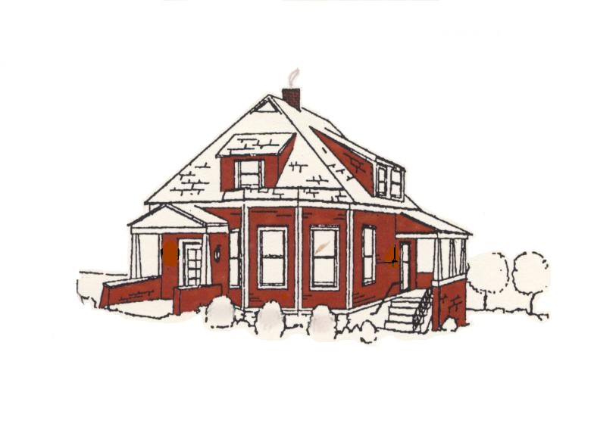
FENTON HISTORICAL SOCIETY
Swantner House
#1 Church Street
Fenton, MO 63026
Phone: 636-326-0808

MEMBERSHIP APPLICATION AND / OR DONATION FORM

Individual Membership $12.00 (Annual)
Family Membership $18.00 (Annual)
Business / Corporation Membership $25.00 (Annual)
Business / Corporation Life Membership $250.00
Individual Life Membership $120.00
Husband and Wife Life Membership $180.00
Donation
Name: Birthday (no year)
Address: Home Phone:
Cell Phone:
E-mail:
Business Name: Bus. Phone:
Business Address: Federal ID:

Business E-mail:
Representative: Title:
Date Paid: Fee Paid: $
Check Cash

Signature(s) of Member(s)
The Fenton Historical Society (“FHS) is a Missouri General Not-for-Profit Corporation incorporated July 9, 1993. Membership in the FHS consists of persons interested in promoting and preserving pride in the history of the Fenton area for future generations and was organized to operate and maintain the “Swantner House” as a depository for and the display of artifacts of Fenton and the surrounding community.

Your support and interest in the Fenton Historical Society and the Swantner House is appreciated.

Date received: By:

“Where the Past . . . and the Present . . . Meet”

